**AMIS**

**AIRPORT MANAGEMENT INFORMATION SYSTEM**

|  |  |  |  |  |
| --- | --- | --- | --- | --- |
| **VERSION** | **DATE** | **DESCRIPTION VERSION** | **AUTHORS** | **QUALITY VERIFIER** |
| 1.0.0 | 26/10/2023 | Initial Version | Miguel Ángel Pinzón Caro | Dra. Maria Paula Morais  Dr. Thiago Andrade Silva  Dra. Maria João da Silva Costa Ferreira  Eng. Celestino  Manuel Baptista de Macedo Alves |
| 1.2.0 | 30/10/2023 | Analysis and basic complementary | Miguel Ángel Pinzón Caro | Dra. Maria Paula Morais  Dr. Thiago Andrade Silva  Dra. Maria João da Silva Costa Ferreira  Eng. Celestino Manuel Baptista de Macedo Alves |

**CONTENT**

**1.** **DEFINITIONS, ACRONYMS AND ABBREVIATIONS** 3

**2.** **BASIC ENGINEERING** 3

**2.1.** **PRODUCT (SOFTWARE) PERSPECTIVE** 3

**2.2.** **SOFTWARE FUNCTIONS** 4

**2.3.** **SOFTWARE SISTEM STAKEHOLDERS** 4

**2.4.** **LIST OF FUNCTIONAL REQUIEREMENTS** 5

**2.5.** **USER STORIES** 6

**2.6.** **ARTEFACTS** 7

**2.6.1.** **USE CASE DIAGRAM** 7

**2.6.2.** **UML DIAGRAM** 7

**2.6.3.** **CLASS DIAGRAM** 7

**2.6.4.** **ACTIVITY DIAGRAM** 7

**2.6.5.** **SEQUENCE DIAGRAM** 7

**3.** **REFERENCES** 7

# **DEFINITIONS, ACRONYMS AND ABBREVIATIONS**

**UPT:** Universidade Portucalense. [1]

**IEEE:** Institute of Electrical and Electronic Engineers. [2]

**AMIS:** Airport management information system.

**Java:** Java is a programming language and computer platform that was developed by Sun Microsystems (now owned by Oracle Corporation). Java is known for being portable, object-oriented, and widely used in software development. [3]

**Data Base:** It is an organized collection of structured information or data, usually stored electronically in a computer system. [4]

**User Interface:** The means by which the user can communicate with a machine, equipment, computer or device, and comprises all points of contact between the user and the equipment. [5]

**Derby:** Open-source relational database written in Java. [6]

**JavaFX:** JavaFX is a platform and a set of software libraries developed by Oracle Corporation that is used to create rich and engaging user interface (UI) applications in the Java programming language. [7]

**Eclipse:** Eclipse is an open-source integrated development environment (IDE) widely used in programming and software development. [8]

**EclipseLink:** Is an open-source persistence framework developed by the Eclipse Foundation. Its main goal is to provide a reference implementation for the Java Persistence API (JPA) specification, which is a standard Java API for object-relational mapping (ORM). [9]

# **BASIC ENGINEERING**

# **PRODUCT (SOFTWARE) PERSPECTIVE**

The main purpose of this project is to develop an airport management information system (AMIS) software for efficient and reliable flight allocation processes depending on the availability of the airline providing the service and the city to which the flight is heading and the city of departure respectively. The AMIS will be designed and developed taking into account the specific needs of the airport's infrastructure and operations, with a focus on improving communication between the personnel who are designated to provide the service.

# **SOFTWARE FUNCTIONS**

1. Access the system by airport officials.
2. For each airport it is necessary to know which flight companies operate.
3. The system must have a record of the name of the airports, the city where it is located and the country in which it operates.
4. Register the passenger in the system database.
5. Managing passengers' personal information.
6. Generate the assignment of a flight to a passenger.
7. Record the cost and flight assignment to a passenger.
8. Register airports, these can be Public and Private.
9. For Private airports must register the companies that sponsor them.
10. For Public airports, you have to register the amount of money that is allocated to you by the government of the respective country.

# **SOFTWARE SYSTEM STAKEHOLDERS**

|  |  |  |
| --- | --- | --- |
| **NAME ROLE** | **ROLE (TYPE OF STAKEHOLDER)** | **ROLE DESCRIPTION** |
| Project Financier  Project Manager (PM)  Developer (DEV)  Quality Assurance (QA)  Engineer DevOps  Designer (UX/UI)  Data Engineer  System Administrator  Regulatory Authorities Governmental  Passengers  Airport IT Manager  Flight Scheduler  Airport Authority  Airline sales agent  Airline Directors  Government agent financing the public airport  Sponsor of private companies | Financial shareholder of the project  Director Project  Project Team  Project Team  Project Team  Project Team  Project Team  Intermediate user- airport staff  Governmental authorities  Final User  Intermediate user- airport staff  Intermediate user- airport staff  Intermediate user- airport staff  Intermediate user- airline staff  Intermediate user- airline staff  Sponsor Airport  Sponsor Airport | This role is the one that finances the project in its entirety.  Responsible for planning, implementing and monitoring projects to achieve specific objectives.[10]  The work of a developer involves designing, implementing, debugging and optimizing software, as well as maintaining and constantly updating the solutions created. [11]  The main objective of QA is to identify and prevent defects in the software, ensuring that the delivered product is reliable. [12]  Professional specializing in the development, implementation and maintenance of practices and tools that pursue continuous integration, continuous delivery (CI/CD) and automation within the software development lifecycle. [13]  Professional in charge of creating digital interfaces that are intuitive, functional and enjoyable for the end user. [14]  Professional for the design, implementation and management of systems and processes that enable the efficient acquisition, storage, transformation and analysis of large volumes of data.[15]  This is the ROLE that has full access to the entire system and its data, with permissions to Create, Modify, Read and access any directory or file.  It is a government authority and audit role, the administrator user gives this role read permissions to read files and directories, but has access to all information in the system.  This role does not interact directly with the system as it is created only for airport officials, it interacts with officials with Airline Sales Agent Roles.  This is the role in charge of the whole communication system in software and infrastructure throughout the airport, this role has access to system log records.  is the role in charge of scheduling and coordinating with the airlines and the availability in each departure and arrival city, this role has access only to information from the airlines, and to the cities.  This role has access only to consult passenger information, in order to corroborate and filter possible offenders.  This role has access to the airline's available flights and seats and cost, as well as access to passenger information in order to assign a seat to a passenger's flight.  This is a role that can only access the sales information of each airline and the information of the sales agent of the airline it manages.  This is the role in charge of financing the public airport with government resources. This person is designated by the government to transfer the necessary resources for the operation of the airport.  It is the representative role of each private company that promotes the resources necessary for the operation of the private airport, this role has access only to investment information at the airport. |

# **LIST OF FUNCTIONAL REQUIEREMENTS**

* **RQAMIS-000:** Login to the system by the administrator with credentials previously created by the software operations team.
* **RQAMIS-001**: Create by the general administrator the respective users with assignment of the roles previously generated by the development team.
* **RQAMIS-002:** Successfully login to the system with their credentials generated by the general administrator user by any user.
* **RQAMIS-003:** Consult the managed airports, indicating separately the public and private airports. For each one of them, the name, the city where it is located and the country to which it belongs must be shown, and all the roles must have access for consultation.
* **RQAMIS-004:** Allow the airline's Sales Manager user to access the available flights offered by the airline to be assigned to a specific passenger user.
* **RQAMIS-005:** Display the companies sponsoring a given airport in case it is a private airport, system administrator, airport management and administration.
* **RQAMIS-006**: Display the amount of subsidy in the case of a public airport by the role of the Governmental Authority, system administrator, airport management and administration.
* **RQAMIS-007:** Show the list of airlines flying from a given airport to that airport.
* **RQAMIS-008:** List all possible flights offered by that airline, showing their identifier, the city of origin and destination and the price of the flight For a particular airline operating at a particular airport.
* **RQAMIS-009:** Show all possible flights (identifier) departing from an origin city to another destination city (indicated by the user) у show their price.
* **RQAMIS-010:** Ability to record and keep up to date the availability of the different airlines for the allocation of flights.
  1. **USER STORIES**

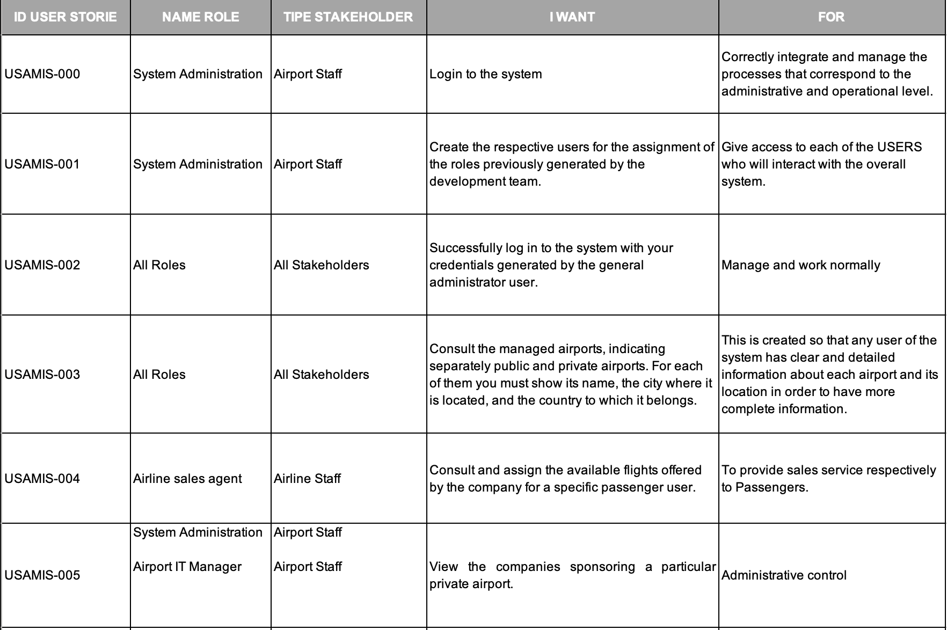

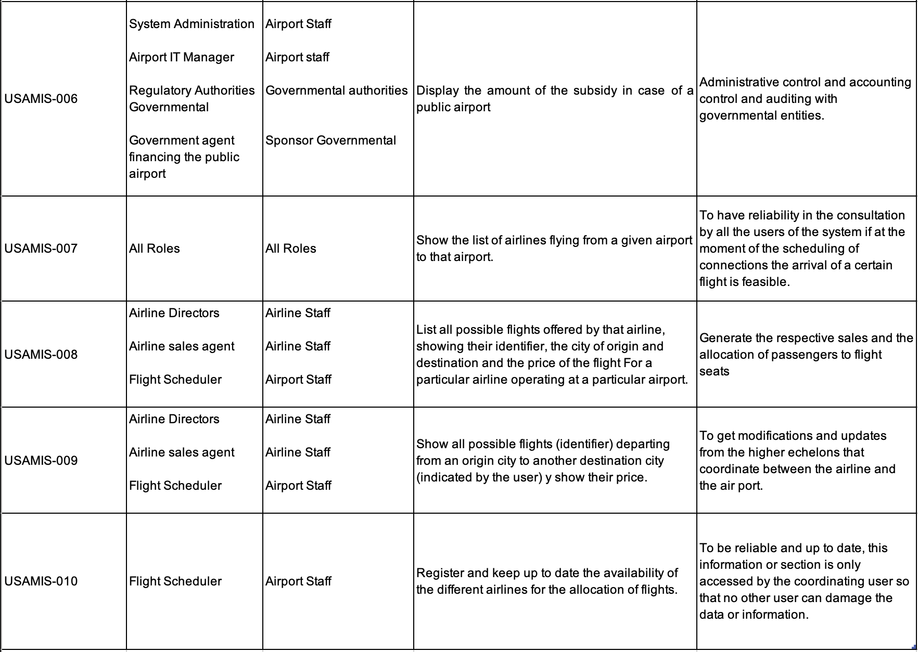

# **ARTEFACTS**

## **USE CASE DIAGRAM**

## **UML DIAGRAM**

## **DATA DIAGRAM**

## **SQL RELATIONAL DATABASE DIAGRAM**

## **GRANT DIAGRAM**

# **REFERENCES**

**(Estándar ISO 690 Referençao Numerica)**

**[1].**[**https://www.upt.pt/inicio/sobre/**](https://www.upt.pt/inicio/sobre/)

**[2].**[**https://www.ieee.org**](https://www.ieee.org)

**[3].**[**https://www.java.com/es/download/help/whatis_java.html**](https://www.java.com/es/download/help/whatis_java.html)

**[4].**[**https://www.oracle.com/co/database/what-is-database/**](https://www.oracle.com/co/database/what-is-database/)

**[5].https://mx.godaddy.com/blog/prototipo-interfaz-usuario-definicion-herramientas/**

**[6].https://www.ibm.com/docs/es/was/8.5.5?topic=resources-about-apache-derby**

**[7]. https://www.java.com/es/download/help/javafx.html**

**[8].** [**https://www.genbeta.com/desarrollo/eclipse-ide**](https://www.genbeta.com/desarrollo/eclipse-ide)

**[9].**[**https://www.campusmvp.es/recursos/post/la-api-de-persistencia-de-java-que-es-jpa-jpa-vs-hibernate-vs-eclipselink-vs-spring-jpa.aspx**](https://www.campusmvp.es/recursos/post/la-api-de-persistencia-de-java-que-es-jpa-jpa-vs-hibernate-vs-eclipselink-vs-spring-jpa.aspx)

**[10].** [**https://www.iebschool.com/blog/project-manager-agile-scrum/**](https://www.iebschool.com/blog/project-manager-agile-scrum/)

**[11].https://unirfp.unir.net/revista/ingenieria-y-tecnologia/desarrollador-software/**

**[12].** [**https://www.hiberus.com/crecemos-contigo/que-es-un-analista-qa/**](https://www.hiberus.com/crecemos-contigo/que-es-un-analista-qa/)

**[13].** [**https://www.redhat.com/es/topics/devops/devops-engineer**](https://www.redhat.com/es/topics/devops/devops-engineer)

**[14].** [**https://neoland.es/que-es-el-ux-ui-design/**](https://neoland.es/que-es-el-ux-ui-design/)

**[15].** [**https://www.iebschool.com/blog/data-engineering-big-data/**](https://www.iebschool.com/blog/data-engineering-big-data/)